**Bottom-Up Parsers**

• A bottom-up parser constructs a parse tree by beginning at the leaves and progressing toward the root.

• Bottom-up parsing starts from the leaf nodes of a tree and works in upward direction till it reaches the root node. Here, we start from a sentence and then apply production rules in reverse manner in order to reach the start symbol. The image given below depicts the bottom-up parsers available.

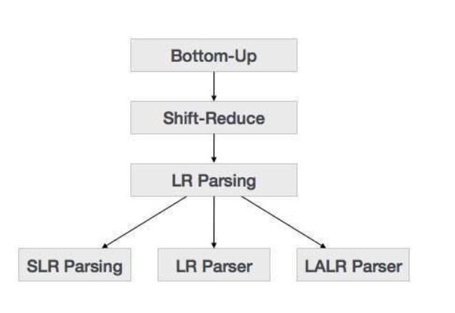

**Shift-Reduce Parsing**

Shift-reduce parsing uses two unique steps for bottom-up parsing. These steps are known as shift-step and reduce-step.

• **Shift step**: The shift step refers to the advancement of the input pointer to the next input symbol, which is called the shifted symbol. This symbol is pushed onto the stack. The shifted symbol is treated as a single node of the parse tree.

• **Reduce step** : When the parser finds a complete grammar rule (RHS) and replaces it to (LHS), it is known as reduce-step. This occurs when the top of the stack contains a handle. To reduce, a POP function is performed on the stack which pops off the handle and replaces it with LHS non-terminal symbol.

**LR Parser**

The LR parser is a non-recursive, shift-reduce, bottom-up parser. It uses a wide class of context-free grammar which makes it the most efficient syntax analysis technique. LR parsers are also known as LR(k) parsers, where L stands for left-to-right scanning of the input stream; R stands for the construction of right-most derivation in reverse, and k denotes the number of look ahead symbols to make decisions.

There are three widely used algorithms available for constructing an LR parser:

SLR(1) – Simple LR Parser:

o Works on smallest class of grammar

o Few number of states, hence very small table

o Simple and fast construction

• LR(1) – LR Parser:

o Works on complete set of LR(1) Grammar

o Generates large table and large number of states

o Slow construction

• LALR(1) – Look-Ahead LR Parser:

o Works on intermediate size of grammar

o Number of states are same as in SLR(1)

**LL vs. LR**

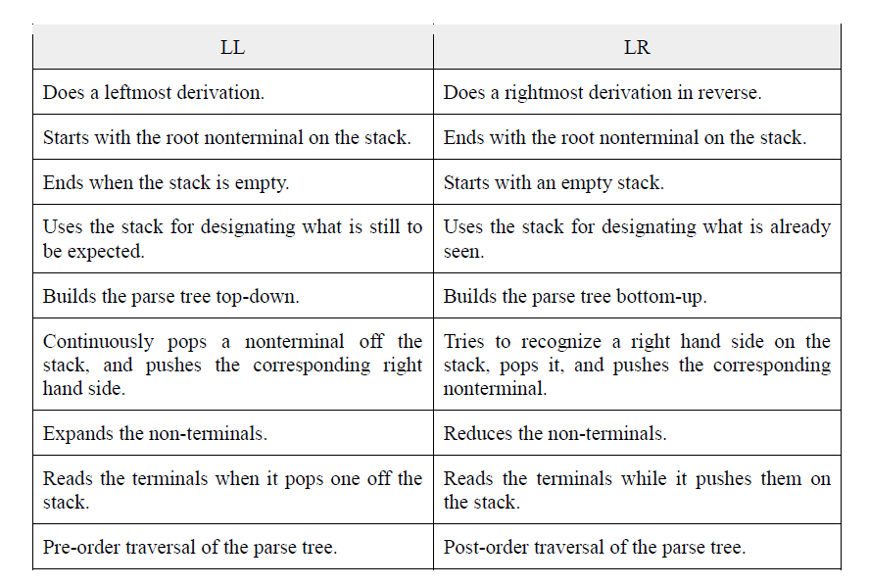

Online Notes

<http://user.it.uu.se/~kostis/Teaching/KT1-11/Slides/handout06.pdf>

<https://www.cs.ucdavis.edu/~pandey/Teaching/ECS142/Lects/bottom.pdf>

<https://web.stanford.edu/class/archive/cs/cs143/cs143.1128/handouts/100%20Bottom-Up%20Parsing.pdf>

Video Links

<https://www.youtube.com/watch?v=RGyzJUM4V0c>

<https://www.youtube.com/watch?v=QTNmobGlqao>

<https://www.youtube.com/watch?v=CdC61wH1Zic>